UNIVERSITA’ POLITECNICA DELLE MARCHE
______________________
FACOLTA’ DI INGEGNERIA


MAXFISH ESP32S3-MATLAB COMMUNICATION
USER MANUAL


V 1.0 from 27 May 2024
Software 3
Hardware 3
Installation 4
Ubuntu 22.04 4
Arduino IDE 2.3.2 4
MATLAB R2023b 4
ROS2 Humble Hawksbill 4
Mosquitto 2.0.18 5
Configuration 6
Pre-Run 6
Run the software 6
Description 7

Software
- Ubuntu 22.04
- Arduino IDE 2.3.2
- MATLAB R2023b
- ROS2 Humble Hawksbill
- Mosquitto 2.0.18

Hardware
- M5CoreS3

Installation

Ubuntu 22.04
If you already have an Ubuntu 22.04 os, skip this step.
We recommend to install the Windows Subsystem for Linux 2(WSL 2).
Run a Command Prompt as administrator, enable WSL inserting:
dism.exe /online /enable-feature /featurename:Microsoft-Windows-Subsystem-Linux /all /norestart
Enable Virtual Machine Platform:
dism.exe /online /enable-feature /featurename:VirtualMachinePlatform /all /norestart
Restart the computer.
Set WSL 2 as default:
wsl --set-default-version 2
Install Ubuntu 22.04:
wsl --install -d Ubuntu-22.04
Set the username and the password for admin.
You should find Ubuntu in your Windows.

Arduino IDE 2.3.2
Install Arduino IDE from the link.
In the Arduino IDE menu, select File -> Preferences.
Copy the url into the Additional Board Manager URLs and save:
https://static-cdn.m5stack.com/resource/arduino/package_m5stack_index.json
In the sidebar, select Board Manager, search for “M5Stack”, and click Install.
In Tools select Board: M5CoreS3.
Install “M5CoreS3 library” in Library Manager and “PubSubClient”.

MATLAB R2023b
Install MATLAB 2023b.
Install ROS Toolbox.

ROS2 Humble Hawksbill
Follow the official guide to install ROS2 Humble Hawksbill.

Mosquitto 2.0.18
Install Mosquitto:
sudo apt update -y && sudo apt install mosquitto mosquitto-clients -y
The default config is only bind to localhost, so to allow listeners to bind to external IP address, add in mosquitto.conf file:
allow_anonymous true
listener 1883 0.0.0.0
and run moquitto, specifying the conf file:
mosquitto -c mosquitto.conf -p 1884

Configuration

Pre-Run
- Modify in pub_sub_esp32s3.ino the ssid and password with your WiFi network. Modify also mqtt_server with your machine’s IP address.
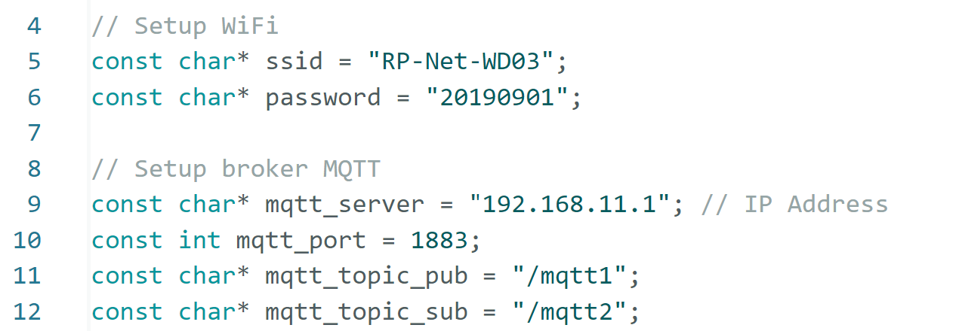
Note: you should connect both the PC and the ESP32S3 to the same WiFi network.
- In BIDbridge.sh change “source /opt/ros/humble/setup.bash” with the path of your ROS2 setup file.
Change MQTT_HOST with your machine IP address.
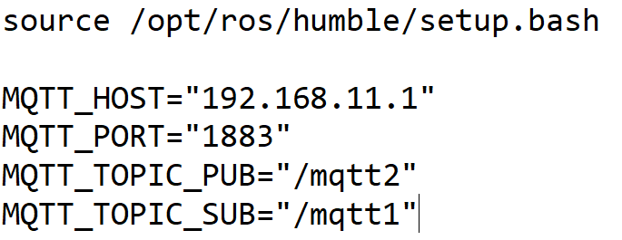

Only for WSL:
Assure to disable the Firewall so that the IP address is accessible.
Configure port forwarding on a Windows command prompt:
netsh interface portproxy add v4tov4 listenport=1883 listenaddress=192.168.11.1 connectport=1883 connectaddress=127.0.0.1

Run the software
- Restart Mosquitto.
- Connect ESP32S3 to the PC and launch the Arduino code.
- Run the BIDbridge.sh file.
- Run the MATLAB code.

Description
This guide explains how to establish a bidirectional connection between an ESP32S3 and MATLAB, using MQTT and ROS2.
The Arduino pub_sub_esp32s3.ino code initializes the WiFi connection and the MQTT broker, then publishes messages to a MQTT topic (/mqtt1), subscribes another MQTT topic (/mqtt2) and waits for messages.
The BIDbridge.sh script creates a bridge between MQTT topics and ROS2 topics. Specifically, it subscribes to /mqtt1, converts messages and sends them to the /locdata ROS2 topic, while simultaneously subscribing to the ROS2 topic /servocmd and sending messages to /mqtt2.
The MATLAB pub_sub_MATLAB.m script starts a ROS2 node, publishes messages to the ROS2 /servocmd topic, subscribes to the ROS2 /locdata topic and waits for messages.
